

**Systems and Database Administration –Journal Entry 1**

**DT211C**

**BSc in Computer Science**

**Tim Browning**

**C14519547**

School of Computing

Dublin Institute of Technology



Contents

Introduction 3

Tasks 3

1. Downloading the Oracle Database Enterprise Edition ISO image 3

2. Setting up the Virtual Machine 5

3. Installing the Oracle Linux ISO image in the virtual machine 6

Conclusions and Reflection 9

Table of Figures

Figure 1 - An image showing which checkbox to select 4

Figure 2 - Installing the Download manager 5

Figure 3 –Loading the ISO 6

Figure 4 - Select Basic Storage Devices Figure 5- Set Root password 6

Figure 6 – Select use all space 7

Figure 7 - Select customise now 7

Figure 8 - Select each checkbox 8

Figure 9 - The installation will begin 8

# Introduction

The objective of this week is to build a virtual machine. The virtual machine will be configured to have Database 11g Enterprise Edition as well as be able to run an oracle database instance. This journal will cover the process it takes to set up the virtual environment running an Oracle Linux operating system.

The virtual machine must meet these requirements:

* Own laptop as a server
* 8GB of internal memory
* Recommended Ram is 2GB
* System storage for the server
* Virtual machine software (VMware or VirtualBox)

# Tasks

Once the computer requirements are met. The next step is to download the Oracle Linux operating system

## 1. Downloading the Oracle Database Enterprise Edition ISO image

The official way to get Oracle Linux is from the their website : <http://www.oracle.com/technetwork/index.html> . Here you can navigate to the downloads page and find a version which is under 7. I chose the version 6.9. To be able to download the ISO; an account must be created. I registered an account by entering my details and a confirmation email was sent within 24 hours.

Finding the correct version of Oracle Linux can be difficult at first because there are a lot of options. The correct one to choose is “*Oracle Linux 6 Update 9 for x86 64 bit, 3.8 GB*”.

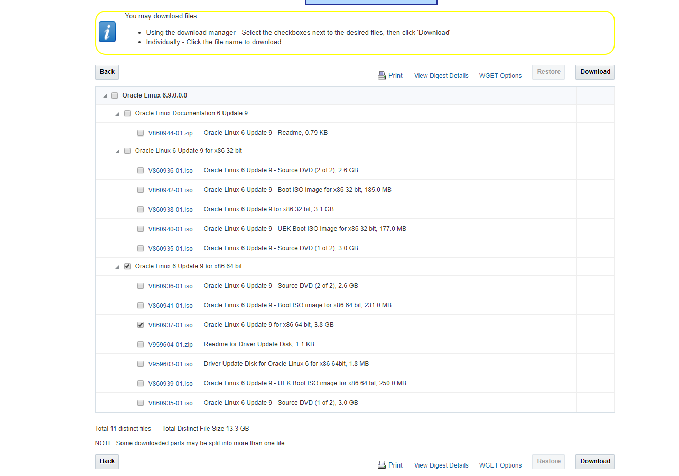

Figure 1 - An image showing which checkbox to select

The other options are updates which are not needed for this assignment. By clicking the download button, you will be asked if you would like to install the download manager. The download manager is necessary to install the ISO. To download is click “*download the installer*”.

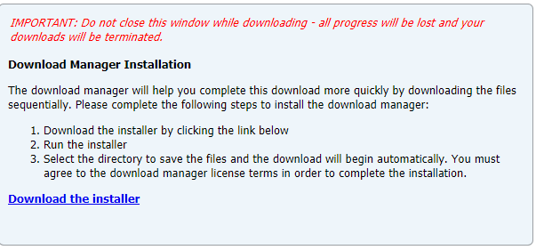

Figure 2 - Installing the Download manager

## 2. Setting up the Virtual Machine

For the virtual machine I had the option between VirtualBox or VMware. Out of convenience I am going to use VirtualBox. The reasons behind this are:

* I have experience using VirtualBox. I have set up servers on VirtualBox before.
* It is already installed on my computer and configured to my personal preferences.

To create a new virtual machine, open up VirtualBox and select the “new” button.

Screens will appear telling you to enter hardware information. Enter in the following:

1. Assign a name: I chose “*Oracle*”.
2. Allocate 2048 MB of RAM. An insufficient amount of RAM can result in the Oracle Instance running very slow.
3. Select VDI for the hard disk type and Dynamic allocation for the disk storage.
4. Allocate 35GB of storage. There must be enough storage to hold the Oracle Enterprise edition 11g.

Once this is completed start the oracle instance. Add The ISO. The ISO file is located in the downloads folder. The ISO is called “*V860937-01.is*o “

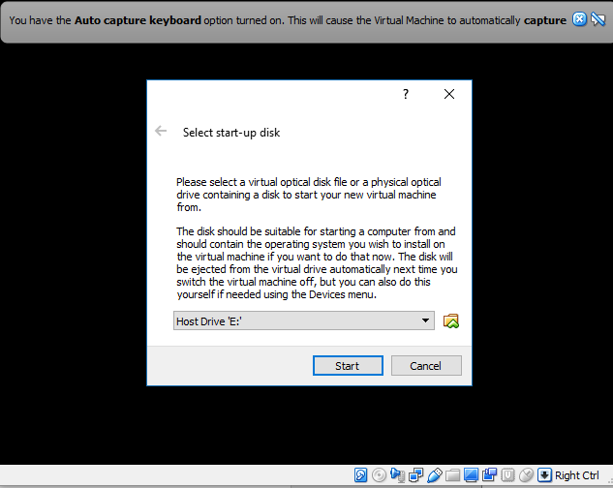

Figure 3 –Loading the ISO

Once loaded select the start button.

## 3. Installing the Oracle Linux ISO image in the virtual machine

The following link is what I followed to install oracle Linux 6.9.

<http://emarcel.com/installing-oracle-linux-6-for-oracle-software/>. The steps from this link and the notes from webcourses allowed me to install a fully functional installation of Oracle Linux. There are many steps to this process. I have left out steps which ask you to enter the time zone or enter a language.

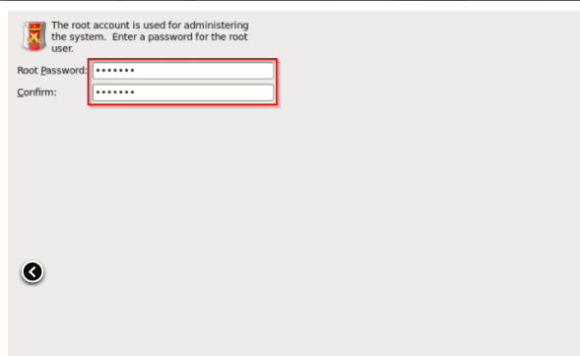

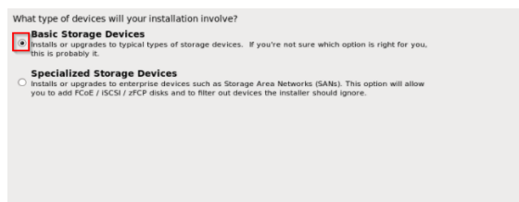

Figure 4 - Select Basic Storage Devices Figure 5- Set Root password

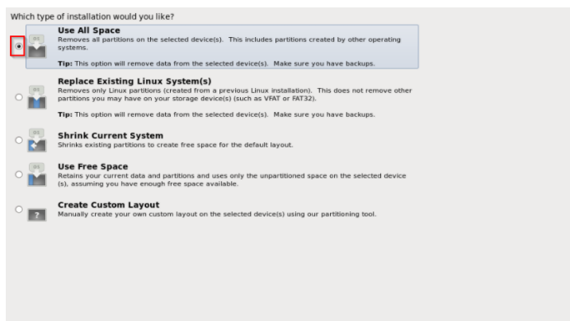

Figure 6 – Select use all space

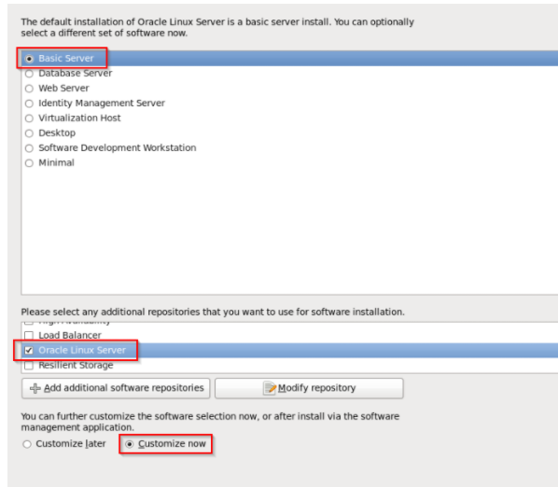

Figure 7 - Select customise now

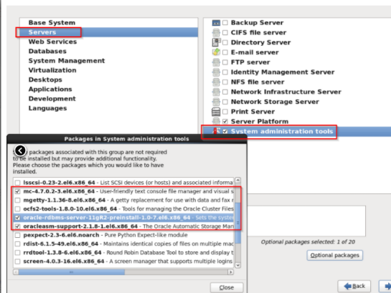 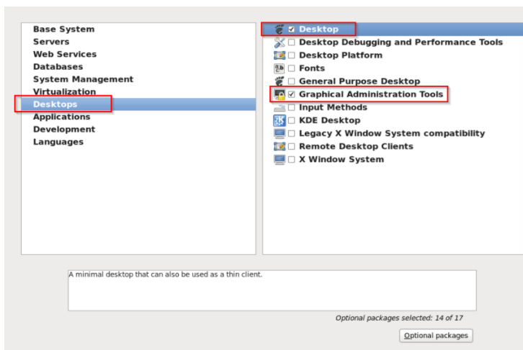

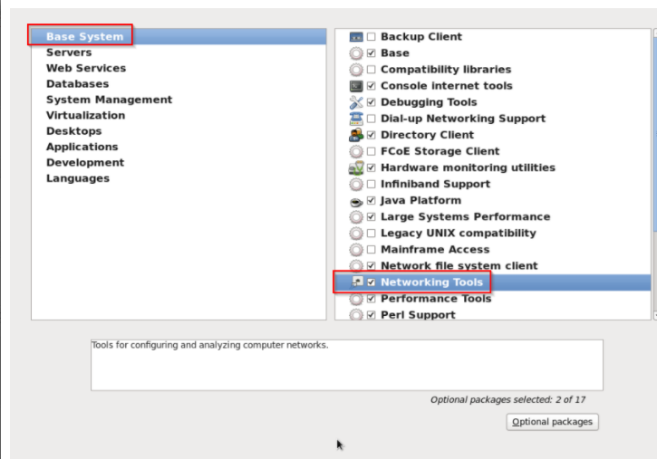

Figure 8 - Select each checkbox

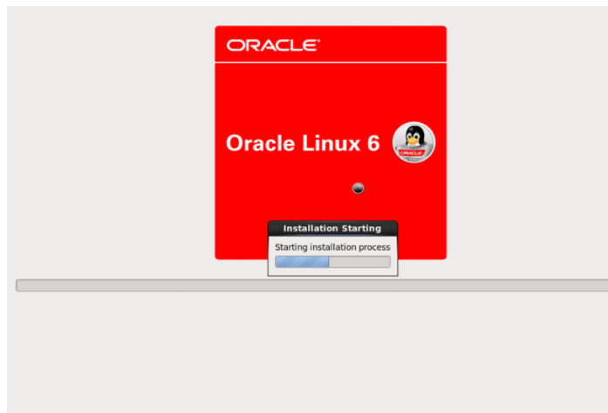

Figure 9 - The installation will begin

On completing these steps, you should have a virtual machine running with oracle database installed. Two accounts have been made available:

Username: root

Username: oracle

The root account gives the user root permissions/access. It is not recommended to use this account. To create a new user login to the “*root*” user. Navigate to users and groups and select “*Add User*”. I created an account called “*Tim*”.

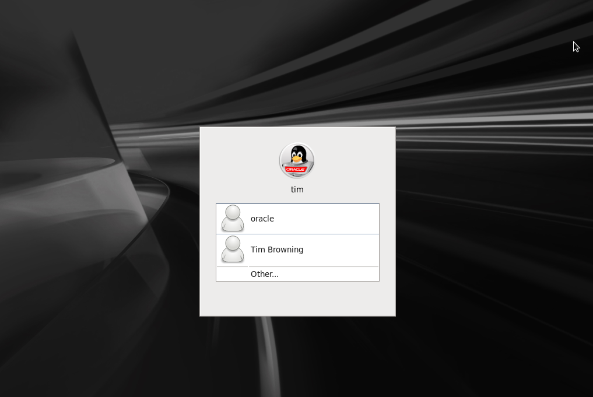

Figure 10 - Login screen

# Conclusion and Reflections

I accidently set 1GB of RAM instead of 2GB. This didn’t cause any problems however as I install more programs and run them simultaneously. I will see performance issues occurring. This was fixed by setting up a new Oracle instance in VirtualBox and re installing Oracle Linux 6.9.

Accessing the root user was an issue for me. A simple error where I didn’t realise you could change the user at the login screen. The mentor provided me with the information needed to login to the root account.

I have had experience with VirtualBox which made this assignment a lot easier. I have set up Linux systems which ran Elasticsearch, CachetHQ and Grafana.

There is plenty of resources out there to help me with this assignment. The big ones being Oracle forums, YouTube and Google. These resources will help me to complete tasks as well as prevent future errors.

For the future tasks I intend to be more careful with each step. One mistake could result in me going backwards rather than forwards. For example the “*RAM*” incident.